Scala – Programming
Scala is a Java-based Hybrid programming language which is the fusion of both Functional and Object-Oriented Programming Language features. It can integrate itself with Java Virtual Machine and compile the code written.
Scala treats every single value as an object and which even includes Functions. Hence, Scala is a fusion of both object oriented language and functional programming.

Mutable VS Immutable Variables
Mutable: We declare the mutable variable using var keyword. The values in the mutable variable supports changes.
Immutable: We declare the immutable variable using the val keyword. The values in Immutable variables doesn’t support changes.

Operators in Scala
The following are the Operators in Scala:
Arithmetic Operators, Relational Operators, Logical Operators, Bitwise Operators, Assignment Operators

String Interpolation
In scala, string interpolation means replacement of defined variables or expressions in a given string with values. String interpolation is used to process string literal in an easy way.
Scala supports mainly three types of string interpolations:
- s String Interpolator
- f String Interpolator: Type safe
- raw String Interpolator: In raw format, the entire string is considered as a raw input
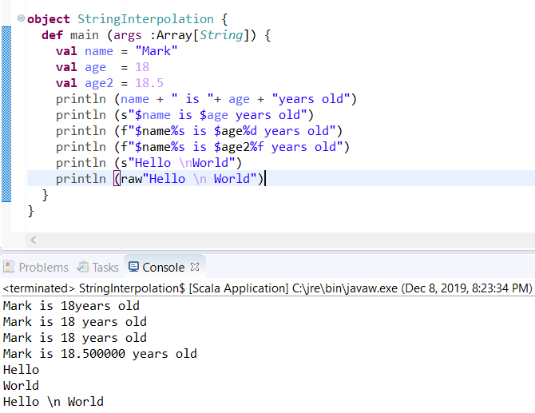

IF ELSE Block
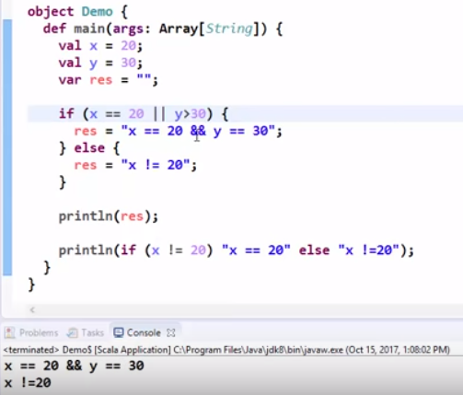
While/ Do – While Loop
In Scala, you can’t write x++ or ++x, it will throw error. You should follow x+=1 convention.
object whileLoop {
def main (args :Array[String]) {
var x =1
var y =1

while (x<= 10)
{
println ("Value of X :" + x)
x+=1
}

println()
do {
println ("Value of Y :"+ y)
y+=1
}
while (y <=10)
}
}
For Loop and Until
In Scala, <- is called the generator operator beyond which we provide the range of iteration
object UntilFor {

def main (args: Array[String]) {
for (i <- 1 to 5) {
println(f"i iterates $i%d times")
}

//another way of writing for loop
for (i <- 1.to(5)) {
println(f"i iterates $i%d times")
}

//until will iterate upto n-1 times
for (i <- 1.until(6)) {
println(f"i iterates until $i%d times")
}

//nested loops
for (i <- 1 to 9; j <- 1 to 3) {
println("i = "+ i +" using multiple ranges for j = "+ j)
}

//list operation using loops
println()
println("List Iteration")
var k=1
val lst= List (2,3,10,12,15,18,20,30,60,80, 90,100)
for (i <- lst) {
println (s"$k element in list is : $i")
k=k+1;
}

println()
println("Using filters while iterating list")
k=1
val lst2= List (2,3,10,12,15,18,20,30,60,80, 90,100)
for (i <- lst; if i <=20) {
println (s"$k element in list is : $i")
k=k+1;
}

println()
println("Using for loop as expression")
val new_lst= for {i <- lst; if i <= 20} yield {
i * i
}
print("New List =")
for (i <- new_lst) {
print(i+ " ")
}
}
}
Match Expression
object MatchExpr {
def main (args: Array[String]) {
val age=90
age match {
case 10 => println(10)
case 20 => println(20)
case 30 => println(30)
case 40 => println(40)
case 50 => println(50)
case 60 => println(60)
case _ => println("default")
}

val result= age.toString() match {
case "10" => age
case "20" => age
case "30" => age
case "40" => age
case "50" => age
case "90" => age
case _ => 0
}
println(result)

//check even or odd number
val i=7
val odd_flag=
i match {
case 1 | 3 | 5 | 7 | 9 => "odd"
case 2 | 4 | 6 | 8 | 10 => "even"
}
println(odd_flag)

}
}

Scala – Streams
A Scala Stream is like a List, except that its elements are computed lazily, in a manner similar to how a view creates a lazy version of a collection. Because Stream elements are computed lazily, a Stream can be long ... infinitely long. Like a view, only the elements that are accessed are computed. Other than this behavior, a Stream behaves similar to a List.
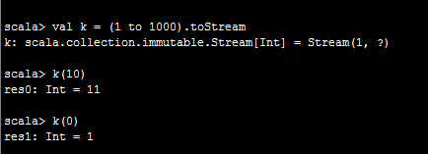
The REPL output shows that the stream begins with the number 1 but uses a ? to denote the end of the stream. This is because the end of the stream hasn’t been evaluated yet.
However, be careful with methods that aren’t transformers. Calls to the following strict methods are evaluated immediately and can easily cause java.lang.OutOfMemoryError errors: stream.max, stream.size, stream.sum

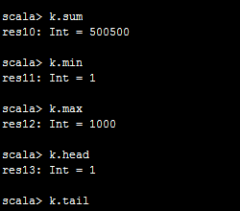
Scala – Trait
A trait is like an interface with a partial implementation. In scala, trait is a collection of abstract or non-abstract methods/functions. You can create a trait that can have all abstract method or some abstract and non-abstract methods.
A variable which is declared either by using var or val keyword in a trait get internally implemented in the class that implements the trait. Any variable which is declared by using val or var but not initialized is considered abstract.
Traits are compiled into java interfaces.

Below example shows a trait with abstract method which is implemented
trait Printable {
def print()
}
class A4 extends Printable {
def print() {
println("Hello from Printable")
}
}
object Trait {
def main (args: Array[String]) {
var a= new A4()
a.print()
}
}

Below example shows a trait with abstract and non-abstract method which is implemented
trait Printable{
def print() // Abstract method
def show(){ // Non-abstract method
println("This is show method")
}
}

class A6 extends Printable{
def print(){
println("This is print method")
}
}

object MainObject{
def main(args:Array[String]){
var a = new A6()
a.print()
a.show()
}
}
Output
This is print method
This is show method

Scala – Class
Classes in Scala are blueprints for creating objects. They can contain methods, values, variables, types, objects, traits, and classes which are collectively called members. Types, objects, and traits will be covered later in the tour.

class Point (var x: Int, var y: Int) {
private var ax = 0 //declaring private variables
private var ay = 0

def move (dx: Int, dy: Int): Unit= {
x= x+ dx
y= y+ dy
}

override def toString: String = {
return s"Value of x : $x" + s"\nValue of y : $y"
}

}

object Point {
def main (args : Array[String]) {
val point1= new Point(20,30)
point1.ax= 10
point1.ay= 50
println(point1)
println(point1.ax)

}
}
This Point class has four members: the variables x and y and the methods move and toString. Unlike many other languages, the primary constructor is in the class signature (var x: Int, var y: Int). The move method takes two integer arguments and returns the Unit value (), which carries no information. This corresponds roughly with void in Java-like languages. toString, on the other hand, does not take any arguments but returns a String value. Since toString overrides toString from AnyRef, it is tagged with the override keyword.

Scala – Tuples
In scala tuple is a collection of elements in ordered form, each with a distinct type. Tuples are immutable. If there is no element present, it is called an empty tuple. You can use tuple to store any kind of data. You can also store mix type of data. You can use it to return multiple values from a function/method.
A tuple with two elements can be created as follows:
val ingredient = ("Sugar" , 25)
The inferred type of ingredient is (String, Int), which is shorthand for Tuple2[String, Int].

One way of accessing tuple elements is by position. The individual elements are named _1, _2, and so forth.

object Tuple {
def tupleFunction() = {
var tuple= (1,2.5, "India")
tuple
}
def main (args: Array[String]) {
val tuple1= (1,2,3,4,5)
val tuple2= ('A', 'B', 'C')
val tuple3= (1,2,3,'A','B','C') //mix tuple

println (tuple1)
println(tuple2)
println( "First element of tuple3 : "+tuple3._1 +"\n"+"Fourth element of tuple3 : "+ tuple3._4)

var tupleValues= tupleFunction()

tupleValues.productIterator.foreach(println)
}
}

Scala – Functions
In scala, functions are first class values. You can store function value, pass function as an argument and return function as a value from other function. You can create function by using def keyword. You must mention return type of parameters while defining function and return type of a function is optional. If you don't specify return type of a function, default return type is Unit.

Scala Parameterized Function:
object MainObject {
def main(args: Array[String]) = {
functionExample(10,20)
}
def functionExample(a:Int, b:Int) = {
var c = a+b
println(c)
}
}

Scala Recursion Function:
object MainObject {
def main(args: Array[String]) = {
var result = functionExample(15,2)
println(result)
}
def functionExample(a:Int, b:Int):Int = {
if(b == 0) // Base condition
0
else
a+functionExample(a,b-1)
}
}

Another Example
object FuncDemo {

object Math {
def add (x:Int=30, y:Int=45):Int= {
return x + y
}

def square (x:Int)= x*x //function in a single line
}

def print (x:Int, y:Int) {
println(x+y)
}

def main (args:Array[String]) {
println (Math.add())
println (Math.add(10,20))
println (Math square 3) //another way of calling funcion only if there is one argument
print(10,10)

val add= (x:Int, y:Int) => x+y //anonymous function

println(add(90,10))
}
}

Scala – Higher Order Functions
Higher order functions take other functions as parameters or return a function as a result. This is possible because functions are first-class values in Scala. The terminology can get a bit confusing at this point, and we use the phrase “higher order function” for both methods and functions that take functions as parameters or that return a function.
In a pure Object Oriented world a good practice is to avoid exposing methods parameterized with functions that might leak object’s internal state. Leaking internal state might break the invariants of the object itself thus violating encapsulation.
object HighOrdFunc {

def double (x:Int): Int= {
x*2
}

def tag_odd_even (x:Int): String ={
if (x%2==0) "EVEN" else "ODD"
}

def main (args: Array[String]) {
val lst= List(3,4,6,8,13)

val lst_double= lst.map(double)
lst_double.foreach(println)

val lst_eveodd= lst.map(tag_odd_even)
for (i <- 0.until(lst.length)) {
println (lst(i) +" is "+ lst_eveodd(i))
}

}
}
One of the most common examples is the higher-order function map which is available for collections in Scala.
val salaries = Seq(20000, 70000, 40000)
val doubleSalary = (x: Int) => x * 2
val newSalaries = salaries.map(doubleSalary) // List(40000, 140000, 80000)

In the below example we see how HOF can take functions as arguments and return functions as well. Below the function returned computes the result.
object HigherOrdFunc {

def math (x:Double, y:Double, f:(Double, Double) => Double): Double = {
f(x,y)
}

def math2 (x:Double, y:Double, z:Double, f:(Double, Double) => Double): Double = {
f(f(x,y), z)
}

def main (args:Array[String]) {
val add= math(10, 20, (x,y)=> x+y) //passing funcions as arguments
val max= math(20, 50, (x,y)=> x max y)
val min= math(60, 10, (x,y)=> x min y)

//print the results
println(add)
println(max)
println(min)

val add2= math2(10, 20, 40, (x,y)=> x+y) //passing funcions as arguments
val max2= math2(20, 50, 70, (x,y)=> x max y)
val min2= math2(60, 10, 5, (x,y)=> x min y)

//print the results
println(add2)
println(max2)
println(min2)
}
}
Output
30.0
50.0
10.0
70.0
70.0
5.0
Scala – Partially applied Functions
Partially applied functions are those which are not applied on all the arguments defined by the stated function i.e. while invoking a function, we can supply some of the arguments and the left arguments are supplied when required.
When we call a function we pass less arguments in it and it doesn’t throws an exception. These arguments which are not passed we use (_) hyphen as placeholder.
object PartialFunc {

def log(date: Date, message:String): Unit= {
println (date + " "+ message)
}

def main(args: Array[String]) {

def Book (discount: Double, cost_price:Double): Double= {
(1- discount/100)*cost_price
}

val discountedPrice= Book(7.5, _: Double)

//display discounted price
println ("Discounted Price : "+ discountedPrice(400))

val date= new Date
val newLog= log(date, _:String)
newLog("This is testing of partially applied functions- 1")
newLog("This is testing of partially applied functions- 2")
}
}
Output
Discounted Price : 370.0
Mon Dec 09 22:31:25 GST 2019 This is testing of partially applied functions- 1
Mon Dec 09 22:31:25 GST 2019 This is testing of partially applied functions- 2
Scala - Coercing Methods into Functions
It is also possible to pass methods as arguments to higher-order functions because the Scala compiler will coerce the method into a function.

case class WeeklyWeatherForecast(temperatures: Seq[Double]) {
private def convertCtoF(temp: Double) = temp * 1.8 + 32

def forecastInFahrenheit: Seq[Double] = temperatures.map(convertCtoF) // <-- passing the method convertCtoF
}

Scala – Closure
A closure uses one or more variables which are declared outside the function.
object Closure {
var number = 10 //this is a free variable and an impure closure
val num = 20 //this is a form of pure cosure
val add= (x: Int) => {
number= number + x
number
}

val sub= (x:Int) => {
if (x > num) x-num else num-x
}

def main (args:Array[String]) {
number=100 //latest value of number is considered inside closure
println (add(20))
println(number)

println(sub(70))
}
}
If the value of the outside variable used inside the function body gets changed it is an impure closure i.e. in the case of using var. But if the value can’t be changed, i.e. in case of val, it is a pure closure.

Scala – Currying Functions
Currying in Scala is simply a technique or a process of transforming a function. This function takes multiple arguments into a function that takes single argument. It is applied widely in multiple functional languages.
object Currying {
//normal function
def add(x:Int, y:Int) = x+y

//currying function
def add2(x:Int)=(y:Int)=> x+y

//currying function provided by scala inbuilt
def add3(x:Int)(y:Int)= x+y

def main (args:Array[String]) {
println(add(10,20))
println(add2(10)(20))

//perform function partially applied using currying function
val add50= add2(30)
println(add50(20))

//perform function partially applied using scala supported currying syntax
val add70= add3(30)_
println(add70(40))
}
}

Scala – List
List is a collection of similar type elements. It’s immutable in nature i.e. once the elements are assigned inside the list it can’t be changed.
object ListOpr {
val myList= List(1,2,4,5,8,9,10)
val names= List("Apple","Banana","Guava","Orange")

def main (args: Array[String]) {

println("Print fruits list")
myList.foreach(println)
for ( i <- names){
print(i+ " ")
}
println()
//append 0 infront of the integer list
println (0 :: myList)

//if you cons anything to Nil, it creates a list
println(1 :: 5 :: 9 :: Nil)
println(myList.head) //prints the first value of the list
println(myList.tail) //prints the list leaving out the first element
println(myList.isEmpty) //returns if list is empty or not
println(names.reverse) //reverse the list elements
println(List.fill(5)(3)) //fills a list with 5 elements where all are 3

println(myList.map(x=> x*2).reduce((x,y)=> x+y)) //map and reduce

//Print total sum of list elements
var sum=0
myList.foreach(sum+=_)
println("List Total :"+ sum)
}
}

Scala – Set
Sets are collection of elements which are again immutable in nature. Besides, sets holds unique elements and no duplicates.
object SetOpr {

val myset: Set[Int]= Set (1,2,4,6,8,3,3)
val names: Set[String]= Set("Apple","Banana","Guava","Grapes")

//to declare a mutable set
val set_mutable= scala.collection.mutable.Set (1,2,3,4,6,9, 10)

def main (args: Array[String]) {
println(myset) //print set shows all values unique as set don't allow duplicates

println(myset+10) //just added 10 to the set output but doesn't change the set
println(myset)

println(names("Orange")) //returns true if the element is present else false
println(names.head)
println(names.tail)
println(names.isEmpty)

println(myset ++ set_mutable) //concatenate two sets
println(myset.++(set_mutable)) //concatenate two sets
println(myset.&(set_mutable)) //intersect two sets - returns common elements
println(myset.intersect(set_mutable)) //intersect two sets

println(myset.max)
println(myset.min)
myset.foreach(println)

for (name <- names) {
print (name + " ")
}
}
}

Scala – Maps
In scala, Maps are unique key value pairs. It is an Iterable collection. Scala’s Predef object offers an implicit conversion that lets you write key -> value as an alternate syntax for the pair (key, value).
object MapOpr {
val mymap: Map[Int, String]=
Map(801 -> "apple", 802 -> "orange", 803 -> "guava", 804 -> "banana", 805 -> "grapes")

def main (args: Array[String]) {
println (mymap)
println(mymap(801))
println(mymap.keys)
println(mymap.values)
println(mymap.isEmpty)

mymap.keys.foreach {key =>
println ("Key "+key)
println ("Value "+ mymap(key))
}

println(mymap.contains(80001)) //check if the key is there or not
if (mymap.contains(80001)) {
println("do some operation")
}
else {
println("don't do some operation")
}
}
}
Output
Map(802 -> orange, 805 -> grapes, 804 -> banana, 801 -> apple, 803 -> guava)
apple
Set(802, 805, 804, 801, 803)
MapLike.DefaultValuesIterable(orange, grapes, banana, apple, guava)
false
Key 802
Value orange
Key 805
Value grapes
Key 804
Value banana
Key 801
Value apple
Key 803
Value guava
false
don't do some operation

